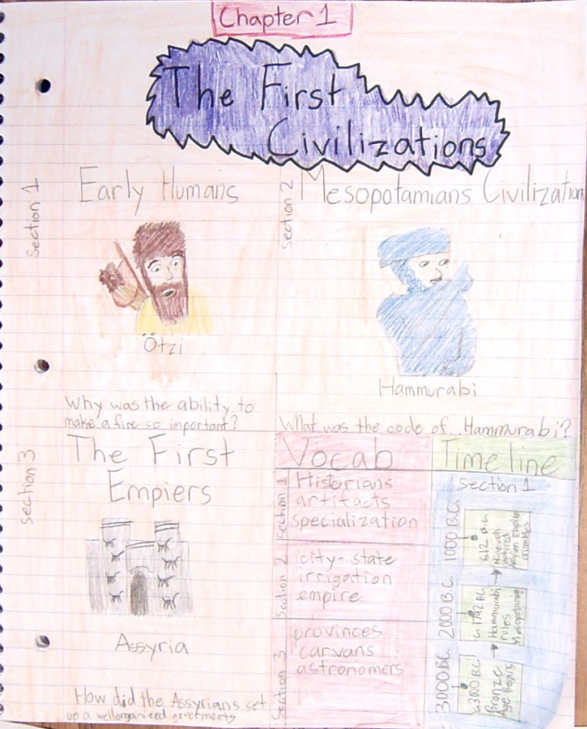
Your cover page should contain:
- Chapter title
- At least one picture from each section
- At least one question from each “section review”
- At least 3 vocab words
- At least three people
- Everything colored (no white)

You could include:
- Questions you have
- More vocab, people, pictures
- Places
- Timelines

Your cover page should contain:
- Chapter title
- At least one picture from each section
- At least one question from each “section review”
- At least 3 vocab words
- At least three people
- Everything colored (no white)

You could include:
- Questions you have
- More vocab, people, pictures
- Places
- Timelines

