Essential Criteria for Effective Writing:
Main Idea/Focus

- Topic or subject is selected by the writer with or without a writing prompt

- If I, the writer, stray from the topic the focus is weakened

- I may state the topic explicitly or develop it inductively

- My piece should have no extraneous or loosely related information

- If I have strong focus, my reader will not be confused

____________________________________________________

My definition:
When I write with strong main idea/focus I will stay on topic. I will not include unnecessary or irrelevant information; this would confuse my audience.

E.C.4.W.
Main Idea/Focus (continued)
Using details to identify the main idea and create a topic sentence.

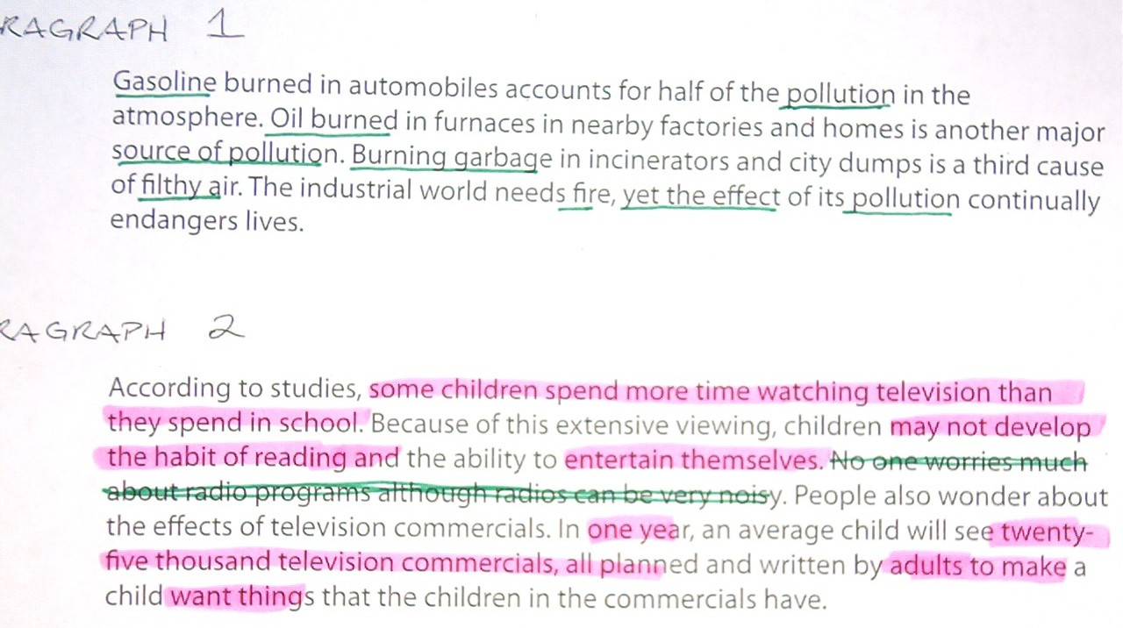

Paragraph 1 topic sentence:
Pollution is produced in a variety ways.

Paragraph 2 topic sentence (cause and effect):
Children around the world are watching too much TV, and it is effecting their ability to learn.

