Science Project:
TRI-FOLD RUBRIC
Tri-Fold Criteria | Points Possible | Points Earned
Uses all or most of the available space (2 points) and includes at least 1 picture of the investigation (2 points) | 4
Title- your problem/question | 2
Introduction- One paragraph about problem. Should include research and identify one key question, it’s answer, and the source | 5
Hypothesis | 4
Materials / Procedures-  Step by step plan for completing the project | 6
Analysis- includes data chart and graphs | 6
Results- a description of your data using words | 6
Conclusion-  What can be learned or proven by your experiment?  Was your hypothesis correct? | 6
Summary- no more than 2 paragraphs reviewing your entire experiment from question to conclusion | 6
Format and Conventions- Neat and organized; easy to read from 7-10 feet away; free of spelling and grammar errors | 5
TOTAL POINTS | 50

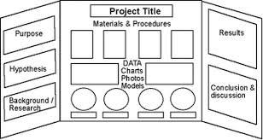
You want your board to look similar to this!!

